<!DOCTYPE html>

<html lang="en">

<head>

<meta charset="UTF-8">

<meta name="viewport" content="width=device-width, initial-scale=1.0">

<title>Amazon clone</title>

<link rel="stylesheet" href="https://cdnjs.cloudflare.com/ajax/libs/font-awesome/6.4.0/css/all.min.css" integrity="sha512-iecdLmaskl7CVkqkXNQ/ZH/XLlvWZOJyj7Yy7tcenmpD1ypASozpmT/E0iPtmFIB46ZmdtAc9eNBvH0H/ZpiBw==" crossorigin="anonymous" referrerpolicy="no-referrer" />

<link rel="stylesheet" href="style.css">

</head>

<body>

<header>

<div class="navbar">

<div class="nav-logo border">

<div class="logo"></div>

</div>

<div class="nav-address border">

<p class="add-first">Deliver to</p>

<div class="add-icon">

<i class="fa-solid fa-location-dot"></i>

<p class="add-sec">India</p>

</div>

</div>

<div class="nav-search">

<select class="search-select">

<option>All</option>

</select>

<input placeholder="Search Amazon" class="search-input">

<div class="search-icon">

<i class="fa-solid fa-magnifying-glass"></i>

</div>

</div>

<div class="nav-signin border">

<p><span>Hello, sign in</span></p>

<p class="nav-second">Account and List</p>

</div>

<div class="nav-return border">

<p><span>Returns</span></p>

<p class="nav-second">& Orders</p>

</div>

<div class="nav-cart border">

<i class="fa-solid fa-cart-shopping"></i>

Cart

</div>

</div>

<div class="panel">

<div class="panel-all">

<i class="fa-solid fa-bars"></i>

All

</div>

<div class="panel-ops">

<p>Today's deals</p>

<p>Customer service</p>

<p>Registery</p>

<p>Gift cards</p>

<p>Sell</p>

</div>

<div class="panel-deals">

Shop deals in Electronics

</div>

</div>

</header>

<div class="hero-section">

<div class="hero-msg">

<p>You are on amazon.com. You can also shop on Amaon India for million of products with fast local delivery. <a>Click here to go to amazon.in</a></p>

</div>

</div>

<div class="shop-section">

<div class="box1 box">

<div class="box-content">

<h2>Revamp your home in style</h2>

<div class="box-img" style="background-image: url('box1.jpg');"></div>

<p>Explore all</p>

</div>

</div>

<div class="box2 box">

<div class="box-content">

<h2>Appliances for your home|Upto 55% off</h2>

<div class="box-img" style="background-image: url('box2.jpg');"></div>

<p>See more</p>

</div>

</div>

<div class="box3 box">

<div class="box-content">

<h2>Customers Most-Loved products</h2>

<div class="box-img" style="background-image: url('box3.jpg');"></div>

<p>Explore all</p>

</div>

</div>

<div class="box4 box">

<div class="box-content">

<h2>Deals on travel tickets you cannot resist</h2>

<div class="box-img" style="background-image: url('box4.jpg');"></div>

<p>See all offers</p>

</div>

</div>

</div>

<footer>

<div class="foot-panel1">

Back to top

</div>

<div class="foot-panel2">

<ul>

<p>Get to Know Us</p>

<a>About Us</a>

<a>Careers</a>

<a>Press Releases</a>

<a>Amazon Science</a>

</ul>

<ul>

<p>Connect with Us</p>

<a>Facebook</a>

<a>Twitter</a>

<a>Instagram</a>

</ul>

<ul>

<p>Make Money with Us</p>

<a>Sell on Amazon</a>

<a>Sell under Amazon Accelerator</a>

<a>Protect and Build Your Brand</a>

<a>Amazon Global Selling</a>

<a>Become an Affiliate</a>

<a>Fulfilment by Amazon</a>

<a>Advertise Your Products</a>

<a>Amazon Pay on Merchants</a>

</ul>

<ul>

<p>Let Us Help You</p>

<a>COVID-19 and Amazon</a>

<a>Your Account</a>

<a>Returns Centre</a>

<a>100% Purchase Protection</a>

<a>Amazon App Download</a>

<a>Help</a>

</ul>

</div>

<div class="foot-panel3">

<div class="logo"></div>

</div>

<div class="foot-panel4">

<div class="pages">

<a>Conditions of Use & Sale</a>

<a>Privacy Notice</a>

<a>Internet Based ads</a>

</div>

<div class="copyright">

© 1996-2024, Amazon.com, Inc. or its affiliates

</div>

</div>

</footer>

</body>

</html>

CSS FILE:

* {

margin: 0;

font-family: Arial;

border: border-box;

}

.navbar {

height: 60px;

background-color: #0f1111;

color: white;

display: flex;

align-items: center;

justify-content: space-evenly;

}

.nav-logo {

height: 50px;

width: 100px;

}

.logo {

background-image: url(amazon\ 10.23.50\ PM.jpeg);

background-size: cover;

height: 50px;

width: 100%;

}

.border {

border: 2px solid transparent;

}

.border:hover {

border: 2px solid white;

}

/** box 2 **/

.add-first {

color: #cccccc;

font-size: 0.85rem;

margin-left: 15px;

}

.add-sec {

font-size: 1rem;

margin-left: 4px;

}

.add-icon {

display: flex;

align-items: center;

}

/** box3 **/

.nav-search {

display: flex;

background-color: pink;

justify-content: space-evenly;

width: 620px;

height: 40px;

border-radius: 4px;

}

.search-select {

background-color: #f3f3f3;

width: 50px;

text-align: center;

border-top-left-radius: 4px;

border-bottom-left-radius: 4px;

border: none;

}

.search-input {

width: 100%;

font-size: 1rem;

border: none;

}

.search-icon {

width: 45px;

display: flex;

justify-content: center;

align-items: center;

font-size: 1.2rem;

background-color: #febd68;

border-top-right-radius: 4px;

border-bottom-right-radius: 4px;

color: #0f1111;

}

.nav-search:hover {

border: 2px solid orange;

}

/** box4 **/

span {

font-size: 0.7rem;

}

.nav-second {

font-size: 0.85rem;

font-weight: 700;

}

/** box6 **/

.nav-cart i {

font-size: 30px;

}

.nav-cart {

font-size: 0.85rem;

font-weight: 700;

}

/** panel **/

.panel {

height: 40px;

background-color: #2223fd;

display: flex;

color: white;

align-items: center;

justify-content: space-evenly;

}

.panel-ops p {

display: inline;

margin-left: 15px;

}

.panel-ops {

width: 70%;

font-size: 0.85rem;

}

.panel-deals {

font-size: 0.9rem;

font-weight: 700;

}

/** hero-section **/

.hero-section {

background-image: url(hero\ image.jpg);

height: 400px;

background-size: cover;

display: flex;

justify-content: center;

align-items: flex-end;

}

.hero-msg {

background-color: white;

color: black;

height: 40px;

display: flex;

align-items: center;

justify-content: center;

font-size: 0.85rem;

width: 80%;

margin-bottom: 25px;

}

.hero-msg a {

color: #007185;

}

/** shop section **/

.shop-section {

display: flex;

justify-content: space-evenly;

background-color: #e2e7e6;

}

.box {

/* border: 2px solid black; */

height: 400px;

width: 23%;

background-color: white;

padding: 20px 0px 15px;

margin: 15px;

}

.box-img {

height: 300px;

background-size: cover;

background-repeat: no-repeat;

margin-top: 1rem;

margin-bottom: 1rem;

}

.box-content {

margin-left: 1rem;

margin-right: 1rem;

}

.box-content p {

color: #007185;

}

/** footer **/

footer {

margin-top: 15px;

}

.foot-panel1 {

background-color: #37475a;

color: white;

height: 50px;

display: flex;

justify-content: center;

align-items: center;

font-size: 0.85rem;

}

.foot-panel2 {

background-color: #222f3d;

color: white;

height: 300px;

display: flex;

justify-content: space-evenly;

}

ul {

margin-top: 20px;

}

ul a {

display: block;

font-size: 0.85rem;

margin-top: 10px;

color: #dddddd;

}

.foot-panel3 {

background-color: #222f3d;

color: white;

border-top: 5px solid white;

height: 70px;

display: flex;

justify-content: center;

align-items: center;

}

.logo {

background-image: url(amazon\ 10.23.50\ PM.jpeg);

background-size: cover;

height: 50px;

width: 100px;

}

.foot-panel4 {

background-color: #0f1111;

color: white;

height: 80px;

font-size: 0.7rem;

text-align: center;

}

.pages {

padding-top: 25px;

}

.copyright {

padding-top: 5px;

}

OUTPUT:

<http://127.0.0.1:5500/Amazon%20clone.html>

**Building a calculator using python and GUI:**

import tkinter as tk

#Function to update the display

def button_click(number):

current = str(display.get())

display.delete(0, tk.END)

display.insert(0, current + str(number))

def clear_display():

display.delete(0, tk.END)

def evaluate_expression():

try:

result = eval(display.get())

display.delete(0, tk.END)

display.insert(0, str(result))

except Exception as e:

display.delete(0, tk.END)

diplay.insert(0, "Error")

#Create the main window

root = tk.Tk()

root.title("Calculator")

#Create a display widget

display = tk.Entry(root, width=16, font=('Arial', 24), bd=8, justify='right')

display.grid(row=0, column=0, columnspan=4)

#Create buttons

buttons = [

('7', '8', '9', '/'),

('4', '5', '6', '*'),

('1', '2', '3', '-'),

('C', '0', '=', '+')

]

#Define button click events

for i, row in enumerate(buttons):

for j, button_text in enumerate(row):

if button_text == '=':

tk.Button(root, text=button_text, padx=20, pady=20, font=('Arial', 20), command=evaluate_expression).grid(row=i+1, column=j)

elif button_text == 'C':

tk.Button(root, text=button_text, padx=20, pady=20, font=('Arial', 20), command=clear_display).grid(row=i+1, column=j)

else:

tk.Button(root, text=button_text, padx=20, pady=20, font=('Arial', 20), command=lambda num=button_text: button_click(num)).grid(row=i+1, column=j)

# Start the main event loop

root.mainloop()

Output:

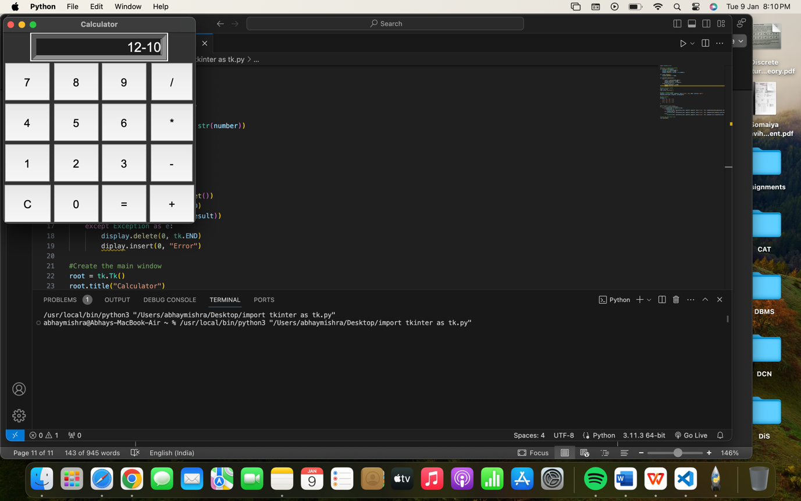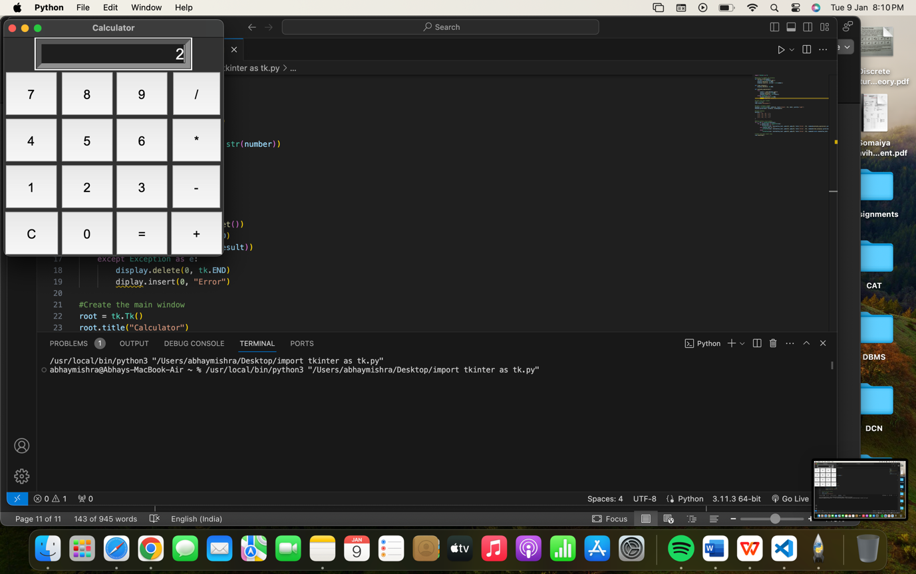

**Building a travel blog page using HTML and CSS:**

HTML Code:

<!DOCTYPE html>

<html lang="en">

<head>

<meta charset="UTF-8">

<meta name="viewport" content="width=device-width, initial-scale=1.0">

<title>Travel Blog</title>

<link rel="stylesheet" href="style.css">

</head>

<body>

<p>Welcome to Lost's Soul Travel Blog</p>

<ul class="navbar">

<li><a href=#">Home</a></li>

<li><a href=#">About Us</a></li>

<li><a href=#">Blog</a></li>

<li><a href=#">Contact</a></li>

</ul>

<main>

<section id="Home">

<h2>Welcome to my Travel Blog</h2>

<p>Explore the world through my adventures.</p>

</section>

<section id="About Us">

<h2>About Me</h2>

<p>I am passionate about travelling and discovering new places.</p>

</section>

<section id="Blog">

<h2>Latest Posts</h2>

<article>

<h3>Post 1:Europe</h3>

<p>Date: May 2, 2016</p>

<p>Description of the travel experience: Exploring Europe was a tapestry of cultural marvels. From the breathtaking architecture of Paris to the serene canals of Venice, each city whispered stories of history and art. The vibrant streets of Barcelona danced with life, while the tranquil Swiss Alps offered a breathtaking escape. Rome's ancient ruins spoke volumes about its glorious past, while the fjords of Norway mesmerized with their raw beauty. Sampling diverse cuisines and immersing in local traditions enriched every moment. Europe, a mosaic of wonders, left an indelible mark, blending centuries-old charm with the thrill of discovering new dimensions at every cobblestoned turn. </p>

<img src="europe1.jpeg" height="200px" width="210px">

<img src="europe2.jpeg" height="200px" width="210px">

<img src="europe3.jpeg" height="200px" width="210px">

<img src="europe4.jpeg" height="200px" width="210px">

<img src="europe5.jpeg" height="200px" width="210px">

<img src="europe6.jpg" height="200px" width="210px">

</article>

<article>

<h3 id=>Post 2: Singapore</h3>

<p>Date: May 15, 2020</p>

<p>Singapore, a vibrant mosaic of cultures and modernity, captivates with its rich tapestry of experiences. The gleaming Marina Bay skyline, adorned with iconic landmarks like the futuristic Gardens by the Bay, dazzles against the night sky. Exploring the historic neighborhoods of Chinatown and Little India immerses you in a blend of traditions, fragrant cuisine, and colorful streets. The bustling hawker centers tease with aromatic delights, offering a culinary journey through diverse tastes. Gardens awash in floral splendor at the Botanic Gardens and the cultural extravaganza at Sentosa Island's attractions weave an enchanting tale of Singapore's multifaceted allure.</p>

<img src="s1.avif" height="200px" width="210px">

<img src="s2.avif" height="200px" width="210px">

<img src="s3.jpeg" height="200px" width="210px">

<img src="s4.webp" height="200px" width="210px">

<img src="s5.jpeg" height="200px" width="210px">

<img src="s6.jpeg" height="200px" width="210px">

</article>

</section>

<section id="Contact">

<h2>Contact Me</h2>

<p>Email id: abc123@gmail.com</p>

<p>Follow me on social media: Instagram-Wanderers_Hub1999</p>

</section>

</main>

</body>

</html>

CSS Code:

p {

text-decoration: underline;

font-size: 30px;

font-weight: bold;

justify-content: center;

text-align: center;

}

.navbar {

background-color: blueviolet;

display: flex;

justify-content: space-evenly;

align-items: center;

}

a {

text-decoration: none;

color: black;

}

li {

list-style-type: none;

color: white;

}

h2 {

align-items: center;

justify-content: center;

}

Output:

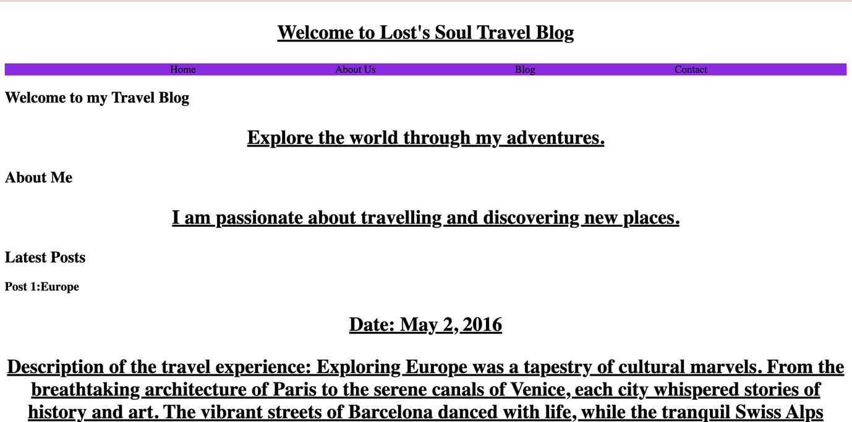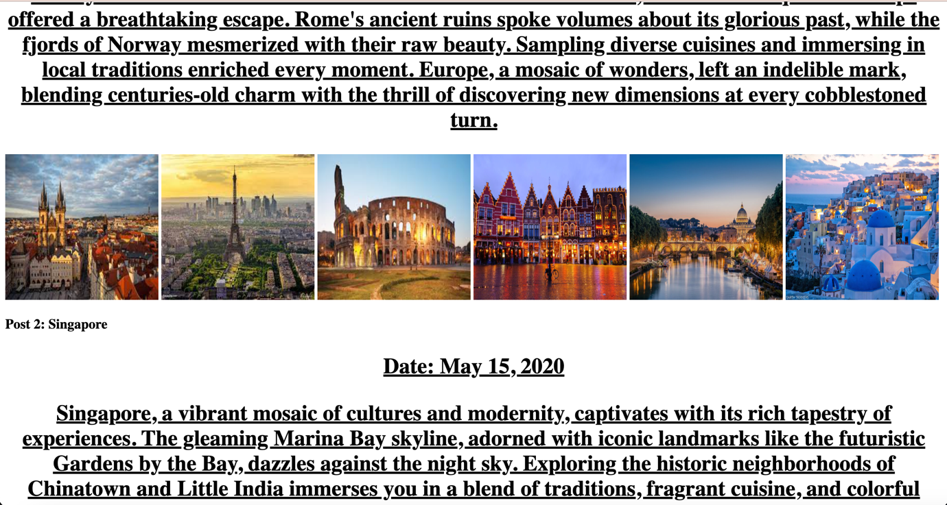

**Building a Registration form using HTML and CSS:**

HTML Code for registration form:

<!DOCTYPE html>

<html lang="en">

<head>

<meta charset="UTF-8">

<meta name="viewport" content="width=device-width, initial-scale=1.0">

<title>Student Registration Form</title>

<link rel="stylesheet" href="style.css">

</head>

<body>

<form action="/action.php">

<h1><u><b>Student Registration form</b></u></h1>

<br>

<br>

<div class="formdesign">

<label for="Name of the student">

<input type="text" placeholder="Username">

</label>

<br>

<br>

<label for="Parents details">

<input type="text" placeholder="Father's Name">

<br>

<br>

<input type="text" placeholder="Mother's Name">

</label>

<br>

<br>

<label for="Guardian's details">

<input type="text" placeholder="Guardian's Name">

</label>

<br>

<br>

<label for="Address details of the student">

<input type="text" placeholder="Permanent Address">

<br>

<br>

<input type="text" placeholder="Residential Address">

</label>

<br>

<br>

<label for="Address details of the guardians">

<input type="text" placeholder="Guardian's Permanent Address">

<br>

<br>

<input type="text" placeholder="Guardian's Residential Address">

</label>

<br>

<br>

<label for="Personal Details">

<input type="text" placeholder="Email id">

<br>

<br>

<input type="password" placeholder="password">

<br>

<br>

<input type="text" placeholder="Date of Birth">

<br>

<br>

<input type="text" placeholder="Age">

<br>

<br>

<input type="text" placeholder="Contact Number">

<br>

<br>

<input type="text" placeholder="Blood group">

</label>

<br>

<br>

<button>Register</button>

<p><b>This is the link to another page.</b></p>

<a href="confirm page.html"><b>Click here to confirm your Registration.</b></a>

</div>

</form>

</body>

</html>

CSS Code for registration form:

.formdesign {

height: fit-content;

max-width: 600px;

border: 2px solid black;

margin: 20px auto;

font-family: Arial, Helvetica, sans-serif;

display: flex;

flex-direction: column;

align-items: center;

justify-content: space-evenly;

}

h1 {

justify-content: center;

align-items: center;

display: flex;

}

body {

background-image: url(img\ \(122\).jpg);

background-size: cover;

}

a {

color: darkblue;

}

Output for registration form:

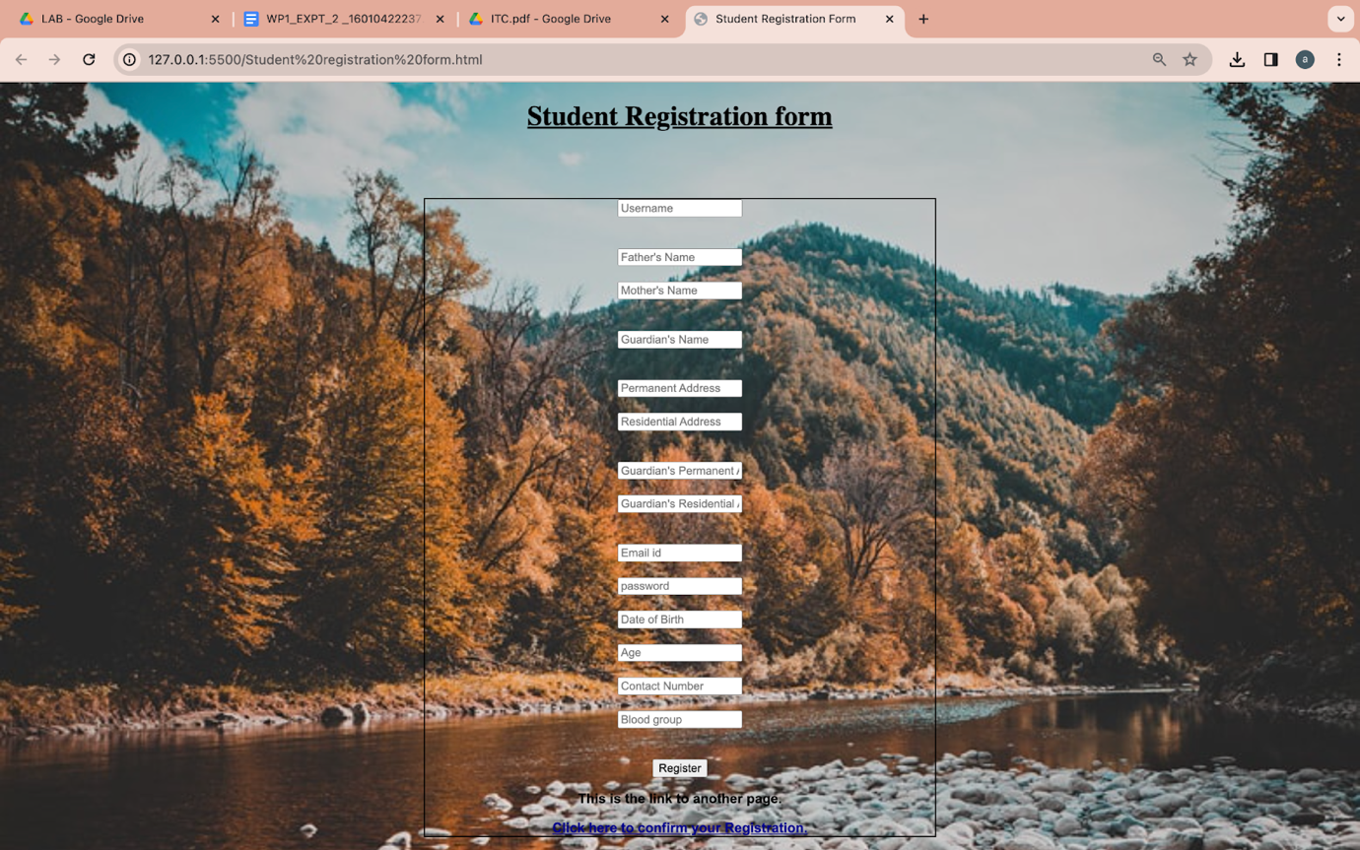

HTML Code for confirmation page of registration form:

<!DOCTYPE html>

<html lang="en">

<head>

<meta charset="UTF-8">

<meta name="viewport" content="width=device-width, initial-scale=1.0">

<title>Confirmation Page</title>

</head>

<body>

<h1>You have successfully registered</h1>

</body>

</html>

Output for confirmation page of registration form:

**Building a game using HTML, CSS AND JS:**

**HTML code:**

<!DOCTYPE html>

<html lang="en">

<head>

<meta charset="UTF-8">

<meta name="viewport" content="width=device-width, initial-scale=1.0">

<title>Rock, Paper and Scissors</title>

<link rel="stylesheet" href="style.css">

</head>

<body>

<h1>Rock, Paper and Scissors</h1>

<div class="choices">

<div class="choice" id="rock">

<img src="rock.png">

</div>

<div class="choice" id="paper">

<img src="paper.png">

</div>

<div class="choice" id="scissors">

<img src="scissors.png">

</div>

</div>

<div class="score-board">

<div class="score">

<p id="user-score">0</p>

<p>You</p>

</div>

<div class="score">

<p id="comp-score">0</p>

<p>comp</p>

</div>

</div>

<div class="msg-container">

<p id="msg">Play your move!</p>

</div>

<script src="first.js"></script>

</body>

</html>

**CSS code:**

* {

margin: 0;

padding: 0;

text-align: center;

}

h1 {

background-color: #081b31;

color: #fff;

height: 5rem;

line-height: 5rem;

}

.choice {

height: 165px;

width: 165px;

border-radius: 50%;

display: flex;

justify-content: center;

align-items: center;

}

.choice:hover {

cursor: pointer;

background-color: #081b31;

}

img {

height: 150px;

width: 150px;

object-fit: cover;

border-radius: 50%;

}

.choices {

display: flex;

justify-content: center;

align-items: center;

gap: 3rem;

margin-top: 5rem;

}

.score-board {

display: flex;

justify-content: center;

align-items: center;

font-size: 2rem;

margin-top: 3rem;

gap: 5rem;

}

#user-score, #comp-score {

font-size: 4rem;

}

.msg-container {

margin-top: 5rem;

}

#msg {

background-color: #081b31;

color: #fff;

font-size: 2rem;

display: inline;

padding: 1rem;

border-radius: 1rem;

}

**JS code:**

let userScore = 0;

let compScore = 0;

const choices = document.querySelectorAll(".choice");

const msg = document.querySelector("#msg");

const userScorePara = document.querySelector("#user-score");

const compScorePara = document.querySelector("#comp-score");

const genCompChoice = () => {

const options = ["rock", "paper", "scissors"];

const randIdx = Math.floor(Math.random() * 3);

return options[randIdx];

};

const drawGame = () => {

msg.innerText = "Game was Draw. Play again.";

msg.style.backgroundColor = "#081b31";

};

const showWinner = (userWin, userChoice, compChoice) => {

if (userWin) {

userScore++;

userScorePara.innerText = userScore;

msg.innerText = `You win! Your ${userChoice} beats ${compChoice}`;

msg.style.backgroundColor = "green";

} else {

compScore++;

compScorePara.innerText = compScore;

msg.innerText = `You lost. ${compChoice} beats your ${userChoice}`;

msg.style.backgroundColor = "red";

}

};

const playGame = (userChoice) => {

//Generate computer choice

const compChoice = genCompChoice();

if (userChoice === compChoice) {

//Draw Game

drawGame();

} else {

let userWin = true;

if (userChoice === "rock") {

//scissors, paper

userWin = compChoice === "paper" ? false : true;

} else if (userChoice === "paper") {

//rock, scissors

userWin = compChoice === "scissors" ? false : true;

} else {

//rock, paper

userWin = compChoice === "rock" ? false : true;

}

showWinner(userWin, userChoice, compChoice);

}

};

choices.forEach((choice) => {

choice.addEventListener("click", () => {

const userChoice = choice.getAttribute("id");

playGame(userChoice);

});

});

Output:

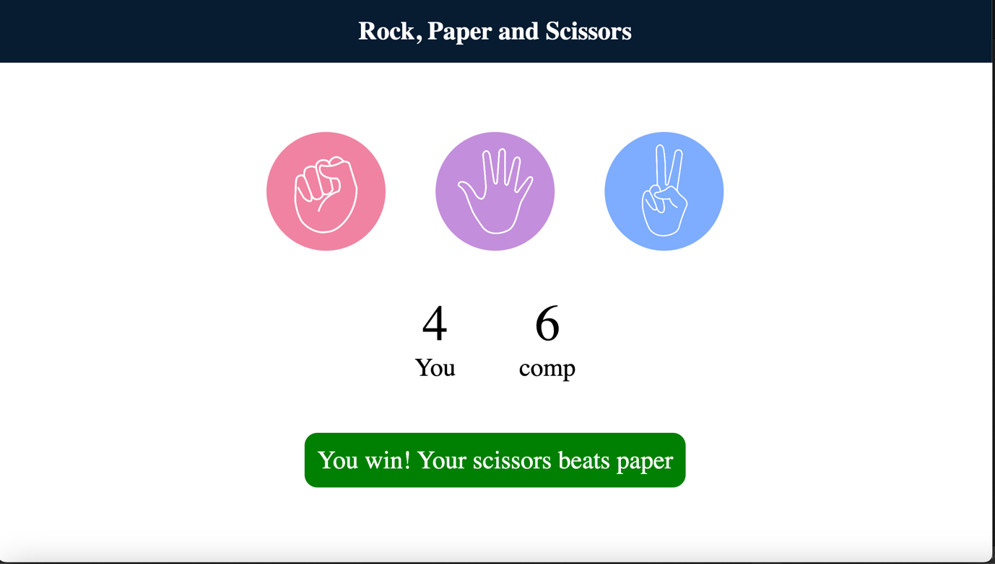

HTML Code for educational website design:

<!DOCTYPE html>

<html lang="en">

<head>

<meta charset="UTF-8">

<meta name="viewport" content="width=device-width, initial-scale=1.0">

<title>Educational website design</title>

<link rel="stylesheet" href="style.css">

</head>

<body>

<div class="section-1">

<nav>

<h1 class="logo">Education <span class="dot"></span></h1>

<ul>

<li><a href="#">Home</a></li>

<li><a href="#">About Us</a></li>

<li><a href="#">Course</a></li>

<li><a href="#">Pages</a></li>

<li><a class="log-in" href="#">Login</a></li>

<li><a class="btn-1" href="#">Get started</a></li>

</ul>

</nav>

<br>

<br>

<div class="container-1">

<div class="contains-1">

<h1>Education is <br> of successful <br> youth</h1>

<br>

<br>

<p>Lorem ipsum dolor sit amet consectetur, adipisicing elit.

<br> Necessitatibus quo consectetur soluta atque beatae dolorem cupiditate dignissimos aut rerum odit blanditiis modi eum, distinctio, et ad ut. </p>

<br>

<br>

<div class="btn-2"><a>Get started</a></div>

</div>

<div class="contains-2">

<img src="banner1.jpg">

</div>

</div>

</div>

</body>

</html>

CSS Code for educational website design:

* {

margin: 0;

padding: 0;

box-sizing: border-box;

font-family: sans-serif;

}

.section-1 {

height: 100vh;

width: 100%;

background-color: #e2e2d2;

position: relative;

padding: 20px 100px;

}

.section-1 nav {

display: flex;

justify-content: space-between;

align-items: center;

}

.section-1 nav.logo {

font-size: 32px;

}

.section-1 nav.logo.dot {

color: #dc143c;

font-size: 45px;

}

.section-1 nav ul li {

list-style: none;

display: inline-block;

padding: 10px 30px;

}

.section-1 nav ul li a {

text-decoration: none;

font-size: 15px;

color: #000;

font-weight: bold;

}

.section-1 nav ul li a:hover {

color: #dc143c;

}

.section-1 nav ul li .log-in {

color: #dc143c;

}

.section-1 nav ul li .btn-1 {

border: 1px solid #dc143c;

color: #dc143c;

padding: 9px 15px;

}

.section-1 nav ul li .btn-1:hover {

color: #fff;

}

.section-1 .container-1 {

display: flex;

justify-content: space-between;

}

.section-1 .container-1 .contains-1 {

margin-top: 80px;

position: absolute;

}

.section-1 .container-1 .contains-1 h1 {

font-size: 60px;

}

.section-1 .container-1 .contains-1 .btn-2 {

padding: 20px 0;

margin-top: 20px;

}

.section-1 .container-1 .contains-1 .btn-2 a {

color: #fff;

background-color: #dc143c;

padding: 12px 20px;

}

.section-1 .container-1 .contains-1 .btn-2 a:hover {

color: #dc143c;

border: 1px solid #dc143c;

background: transparent;

}

.section-1 .container-1 .contains-2 img {

padding-right: 50px;

height: 300px;

width: 300px;

position: relative;

transform: translate(550px,0px);

}

Output:

